**ChromHMM Report**

**ChromHMM results is found in:**

Folder: ~/DeborahOganyaOgenyi/OMICS4/learnModel

**file:///C:/Users/DEBBY/Documents/OMICS4/webpage_10.html**

**Number of States:** 10

**Assembly:** hg19

ChromHMM helps annotate the non-coding genome using epigenomic information across one or multiple cell types. It combines multiple genome-wide epigenomic maps, and uses combinatorial and spatial mark patterns to infer a complete annotation for each cell type. ChromHMM learns chromatin state signatures using a multivariate hidden Markov model that explicitly models the combinatorial presence or absence of each mark.

ChromHMM uses these signatures to generate a genome-wide annotation for each cell type, by calculating the most probable state in each genomic segment. ChromHMM provides automated enrichment analysis of the resulting annotations to facilitate the functional interpretations of each chromatin state. ChromHMM is distinguished by its modeling emphasis on combinations of marks, its tight integration with downstream functional enrichment analyses, its speed, and its ease of use.

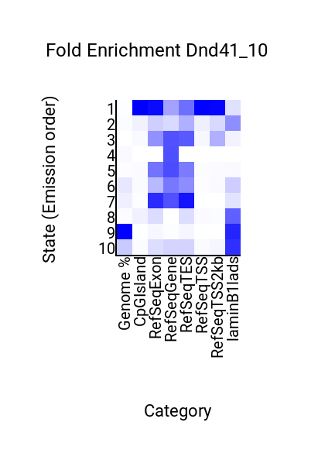

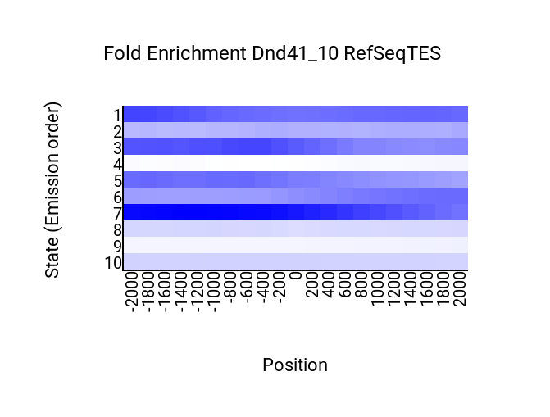

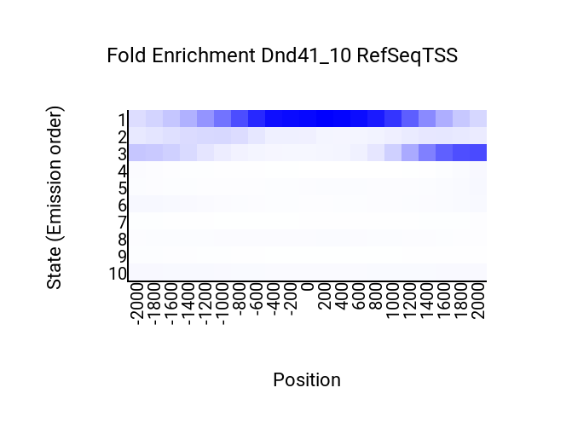

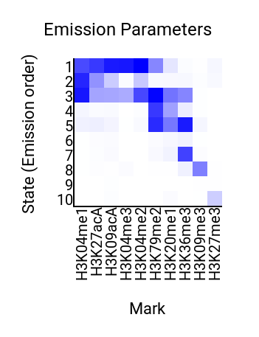

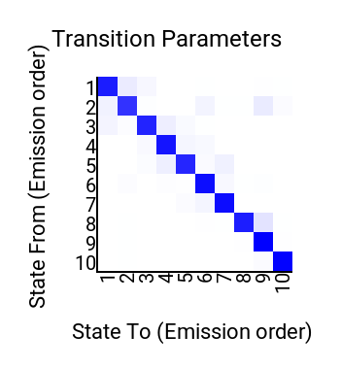

**EPIGENETIC STATES, FEATURES AND NAME**

|  |  |  |  |
| --- | --- | --- | --- |
| **Epigenetic State** | **Features** | **Name** | **Colour** |
| State 1 | Transcriptional elongation | H3k04me1 | Dark blue |
| State 2 | Transcriptional transition | H3k27acA | Light blue |
| State 3 | Strong Enhancer | H3k09acA | Lime |
| State 4 | Weak insulator | H3k04me2 | Light green |
| State 5 | Strong Enhancer | H3k04me1 | Purple |
| State 6 | Weak/poised promoter | H3k79me2 | Dark green |
| State 7 | Weak enhancer | H3k20me1 | Red |
| State 8 | Weak enhancer | H3k36me3 | brown |
| State 9 | Active promoter | H3k09me3 | yellow |
| State 10 | Strong enhancer | H3k27me3 | Pink/light purple |

**Pictures of visualization from IGV**

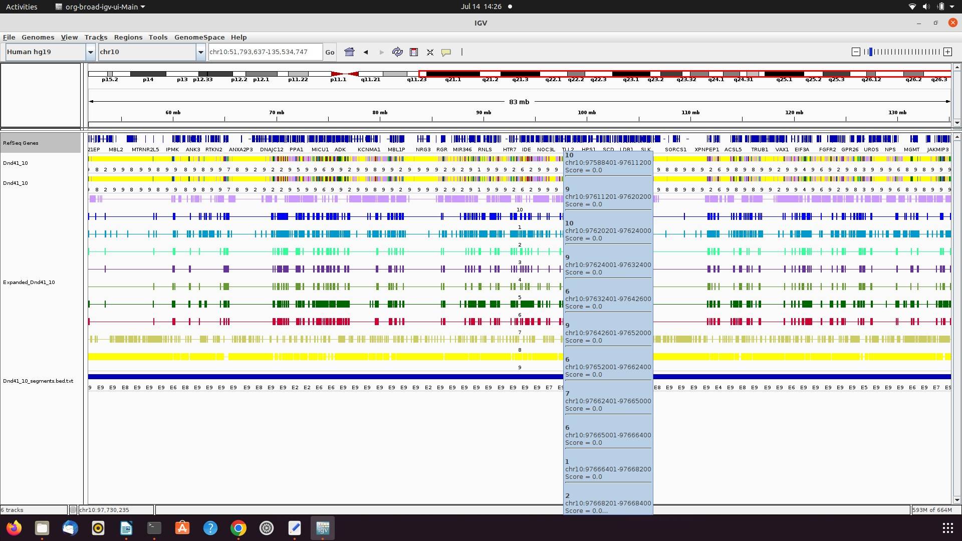

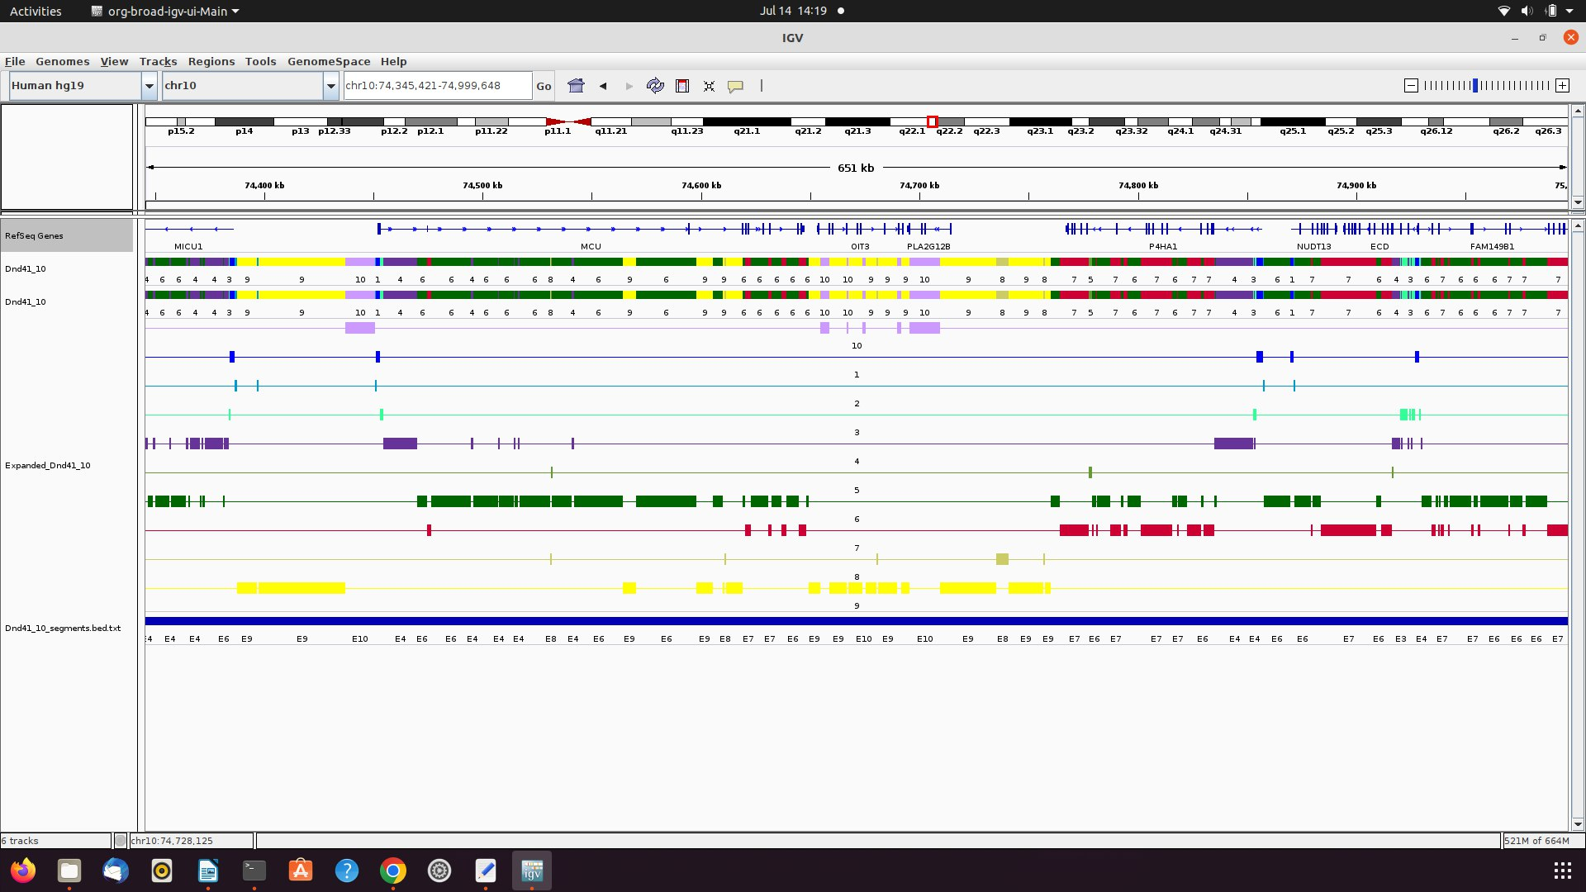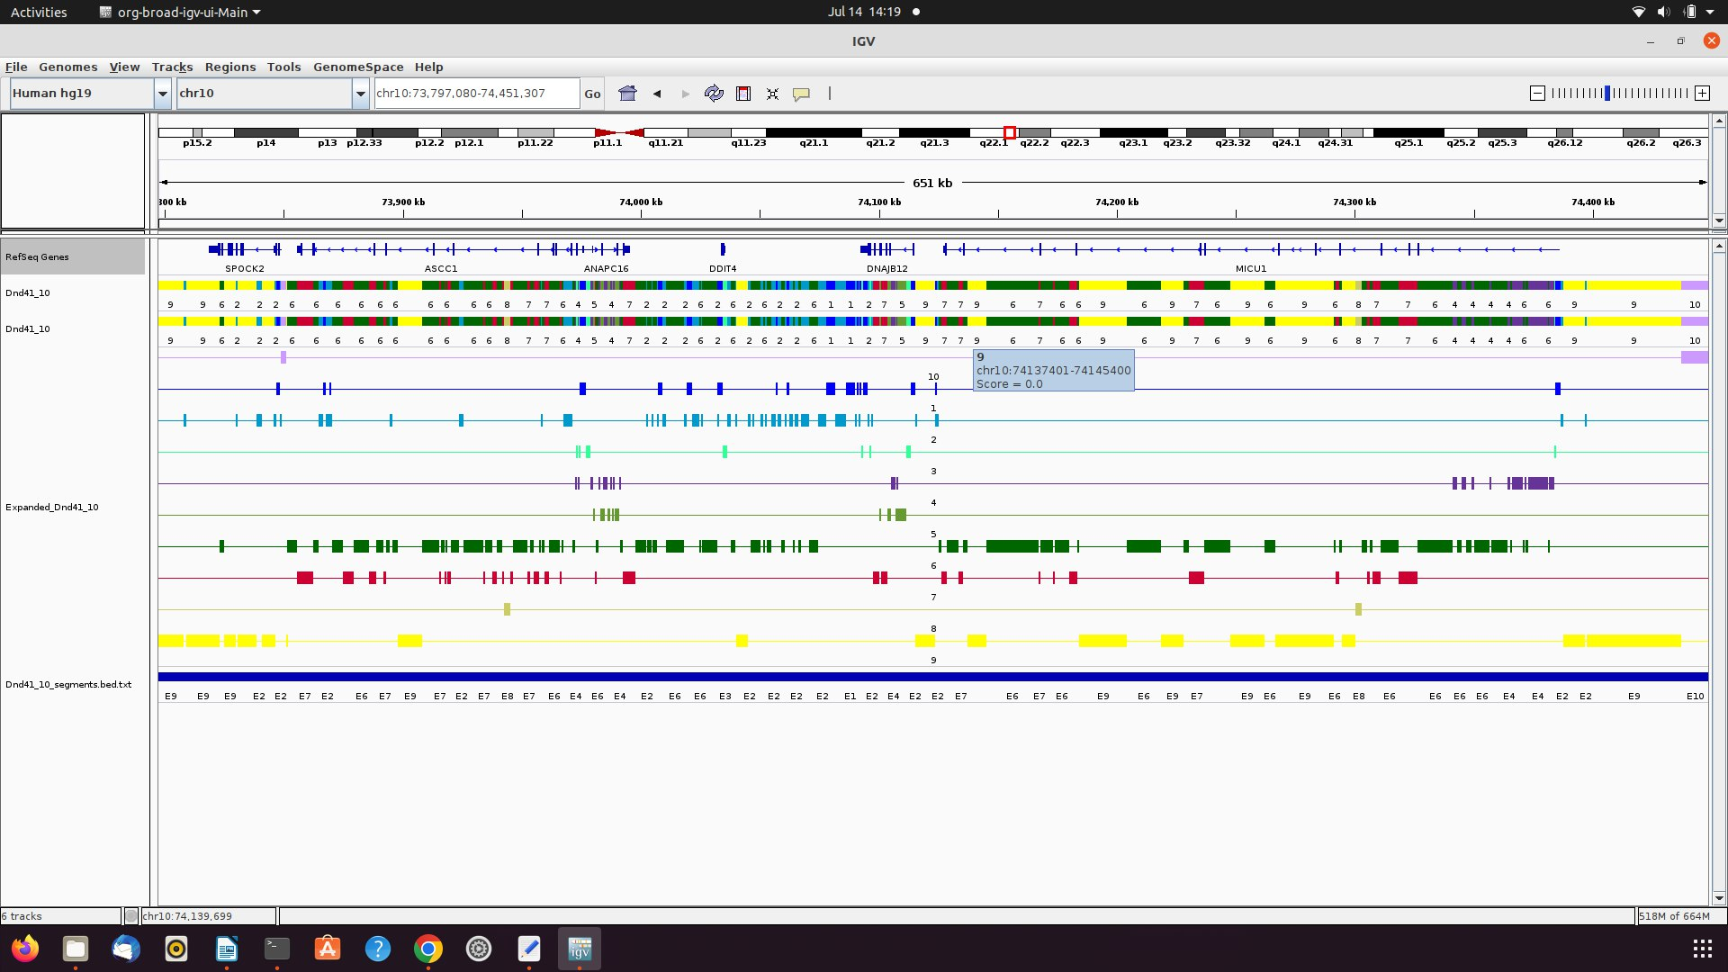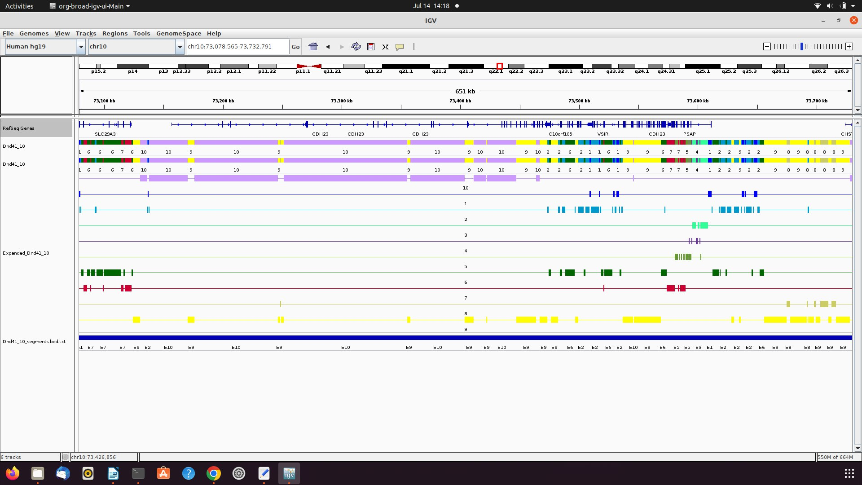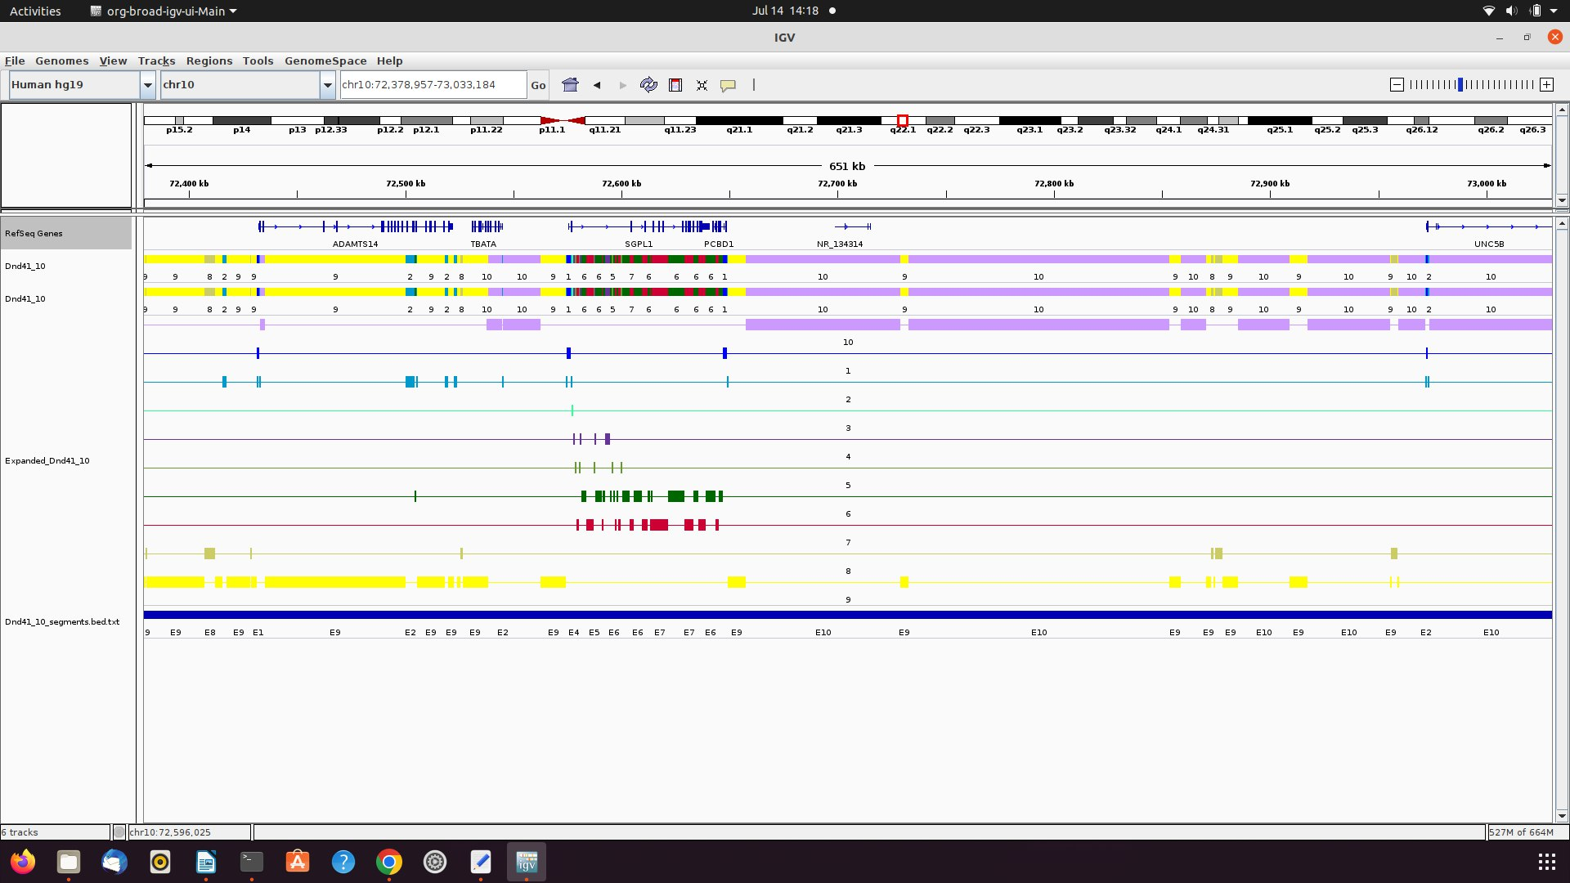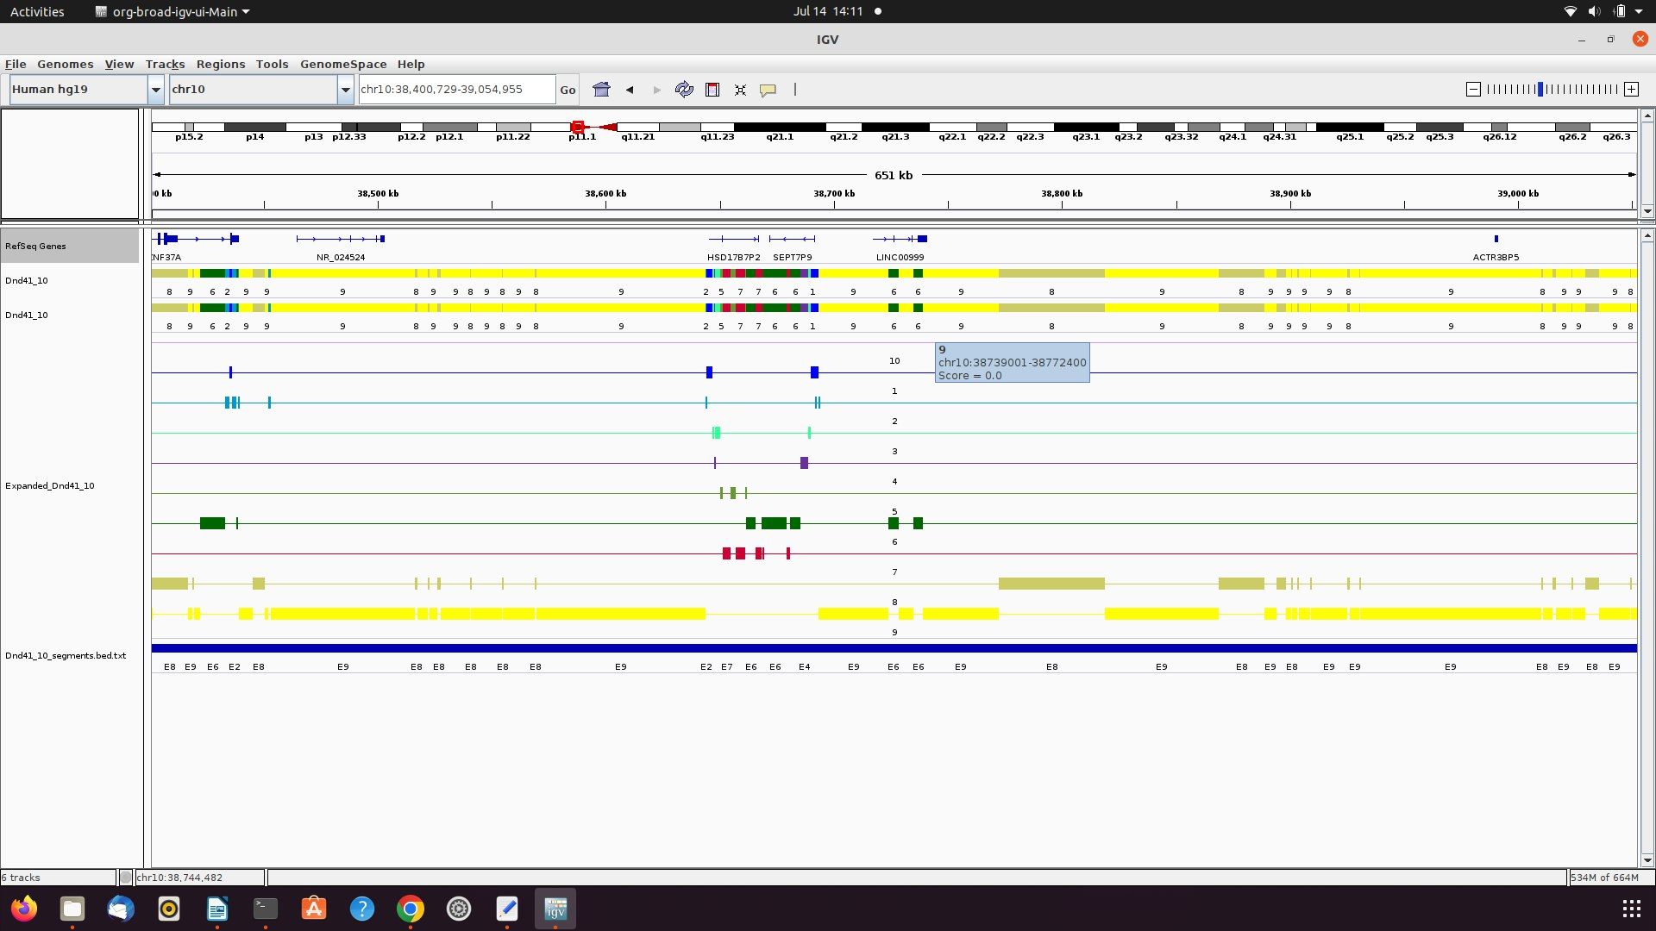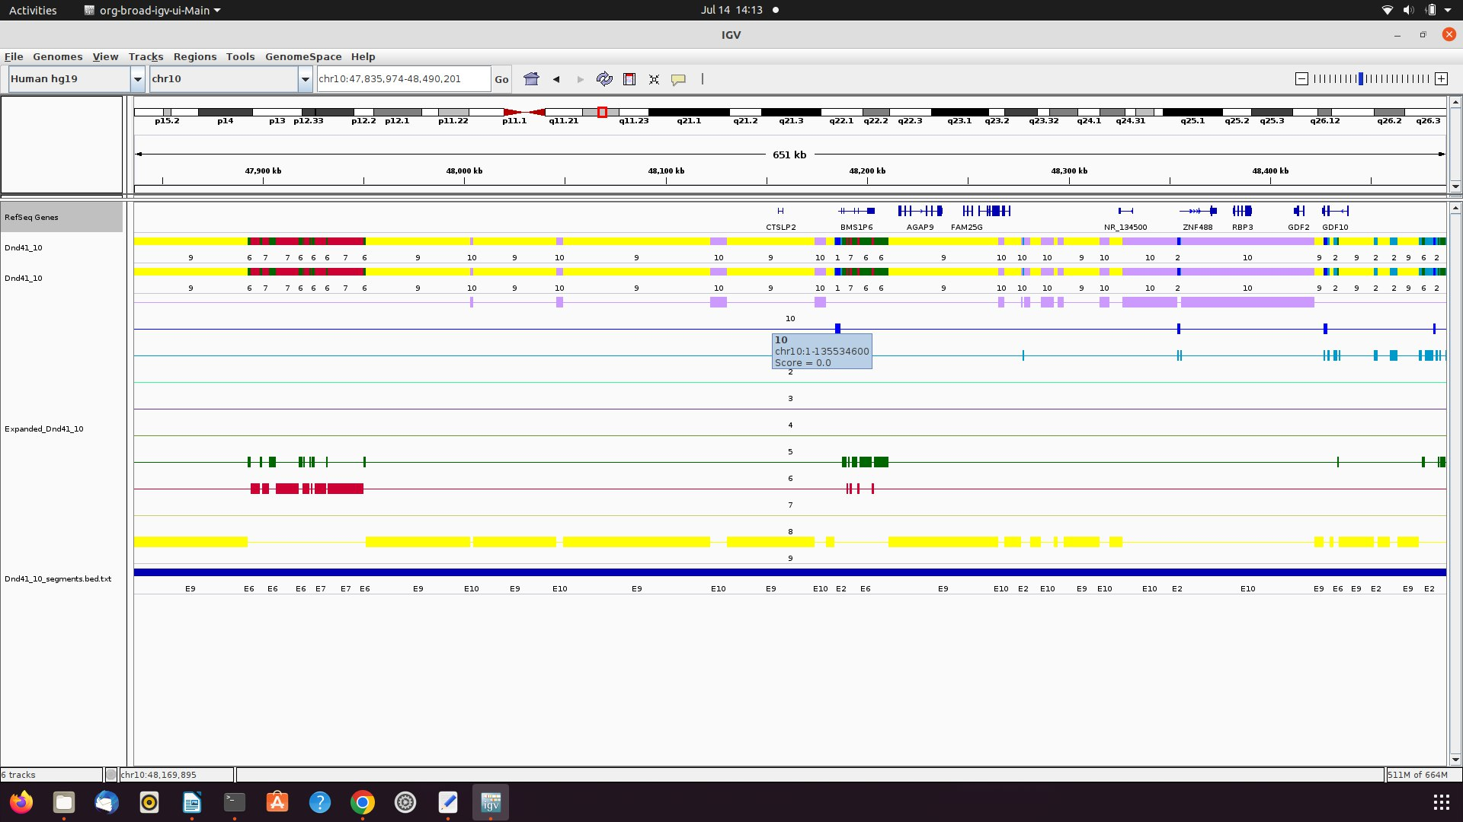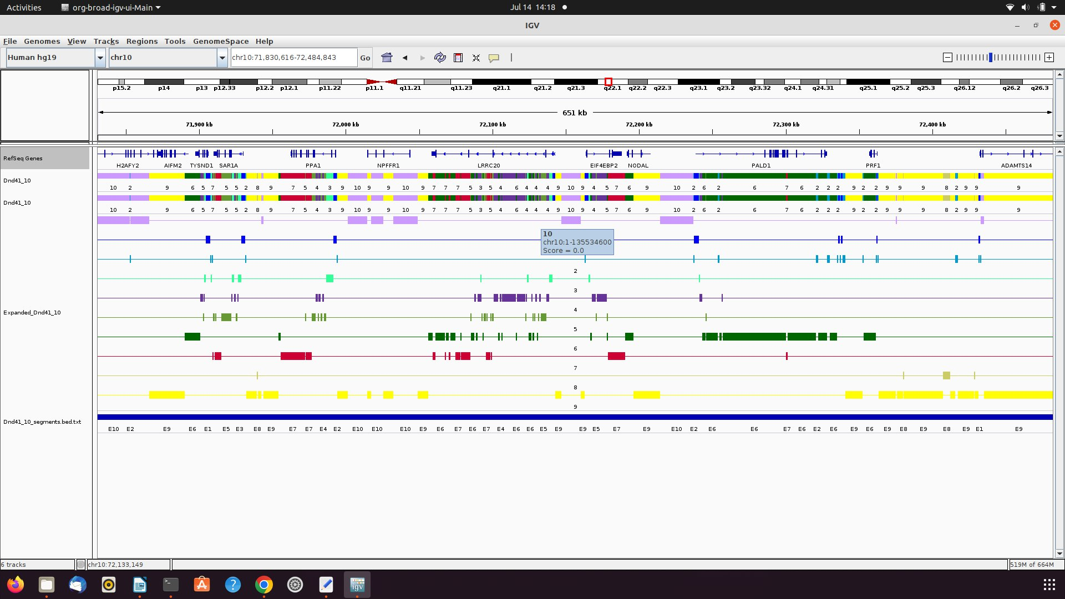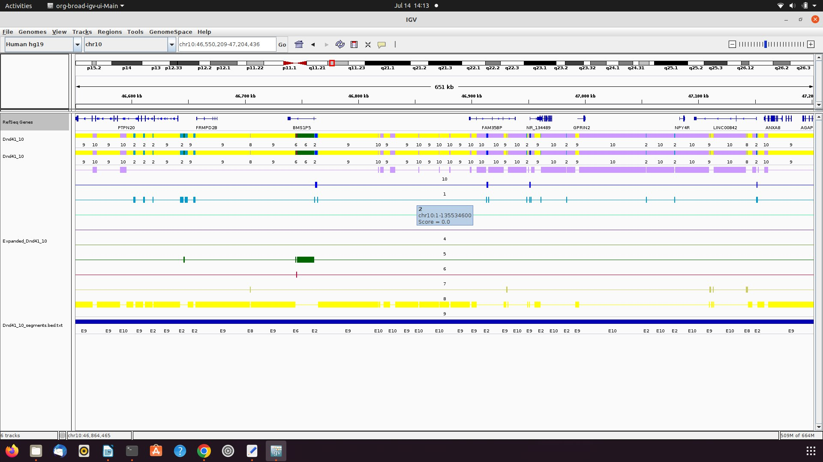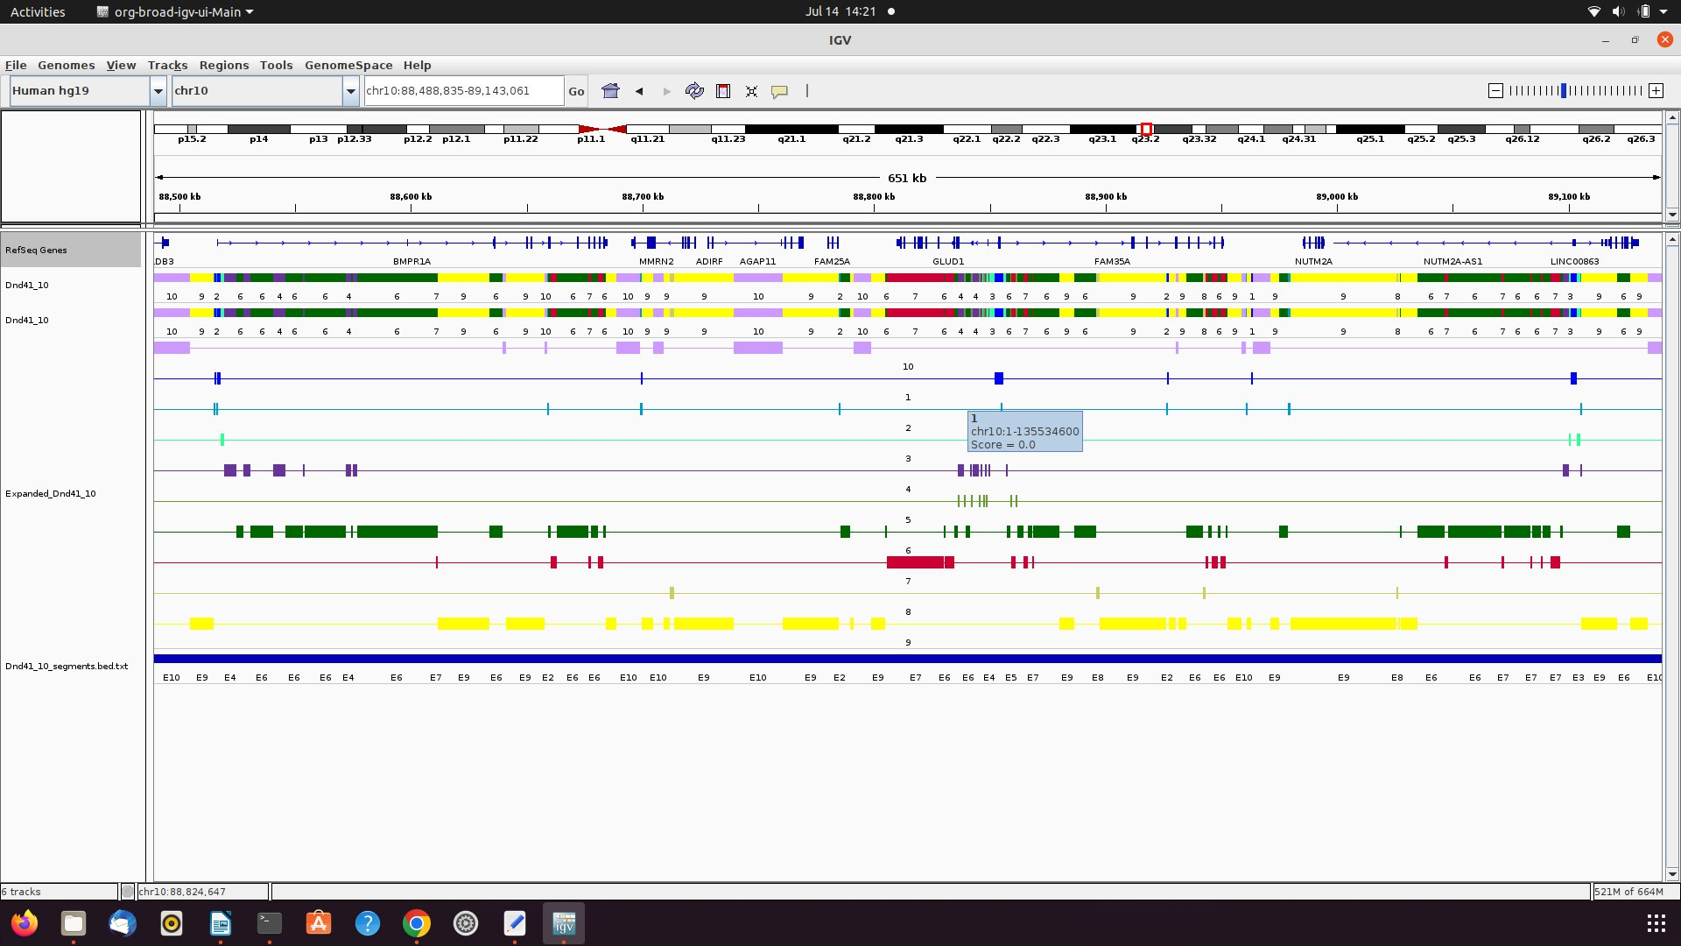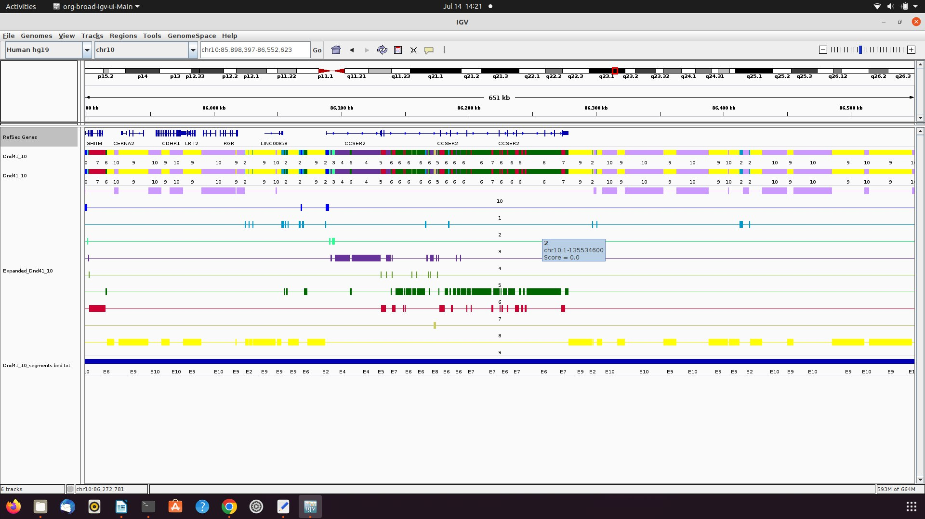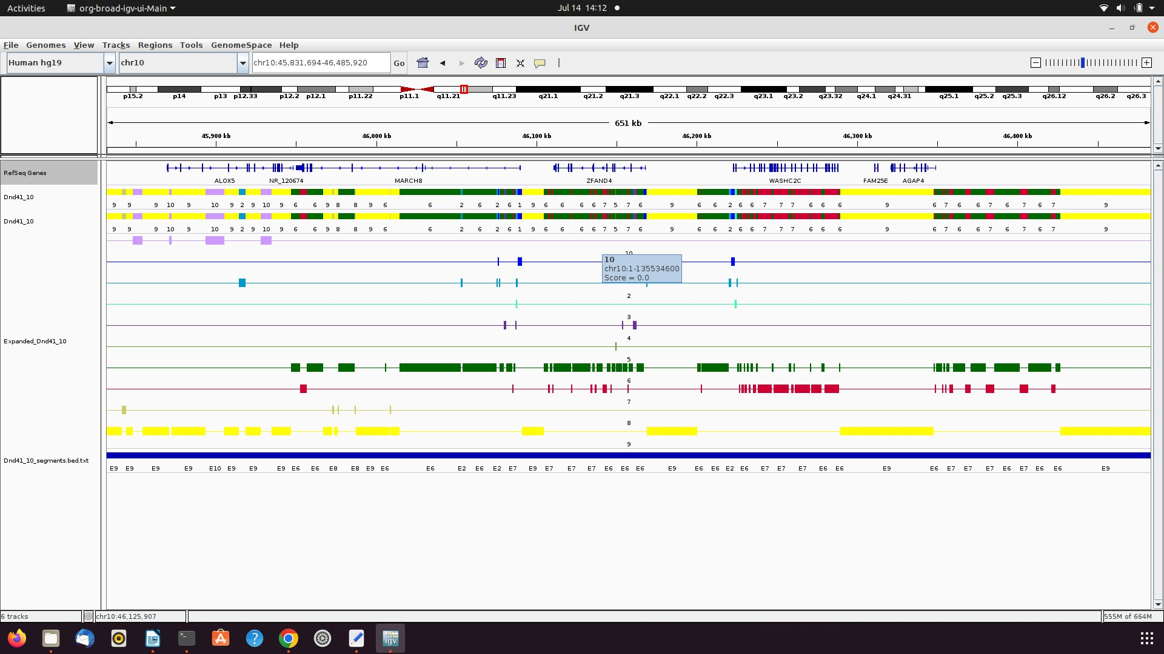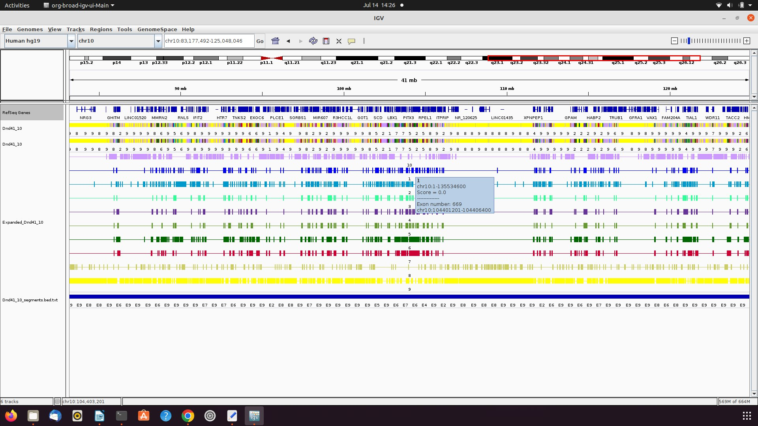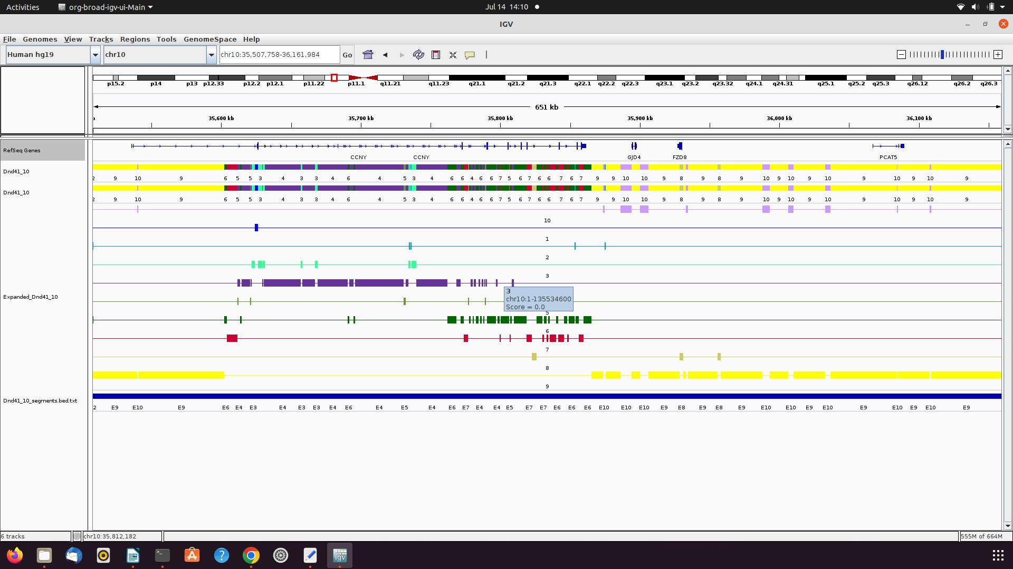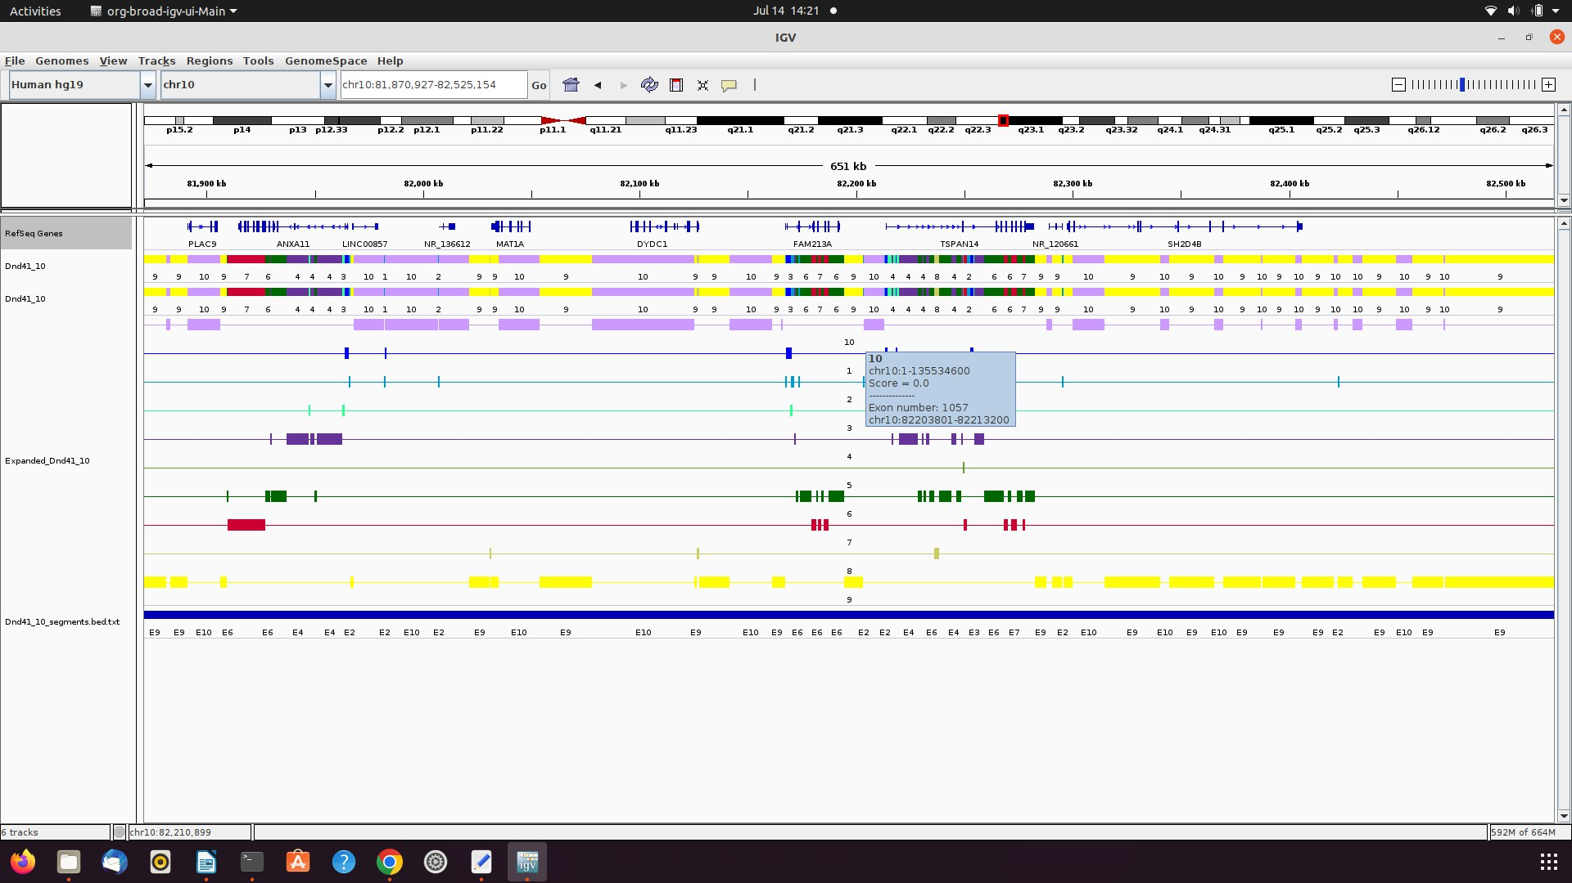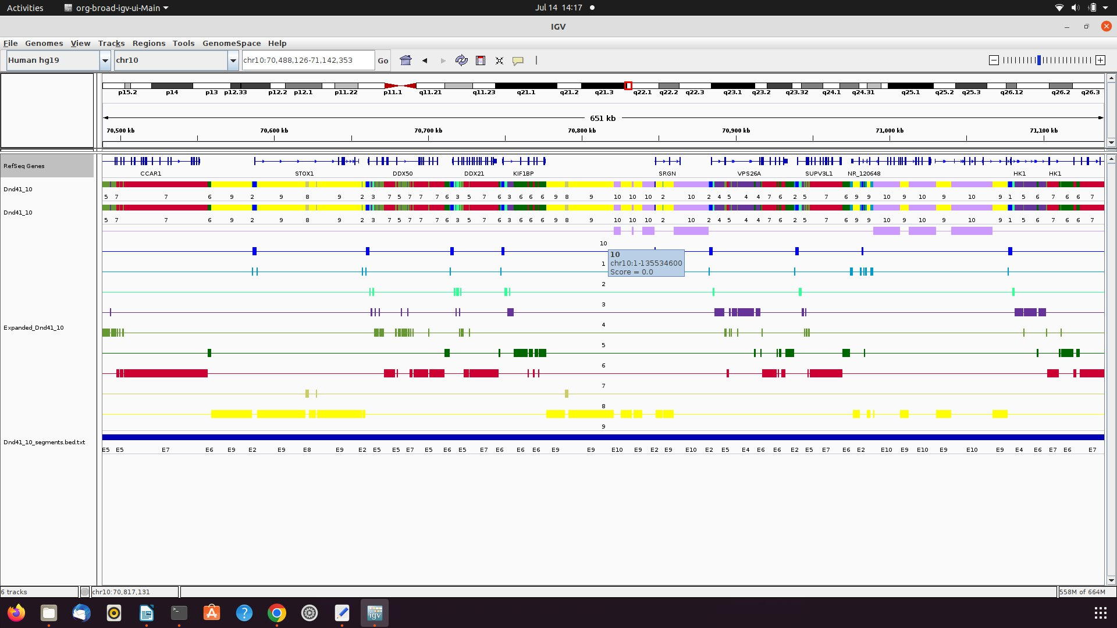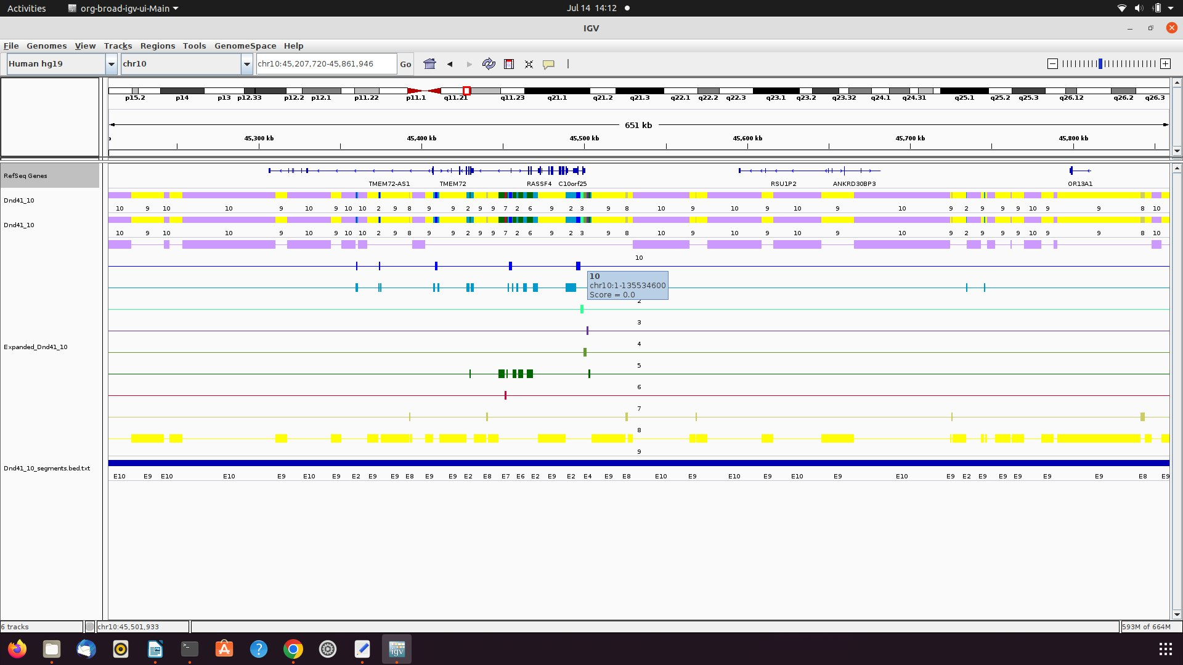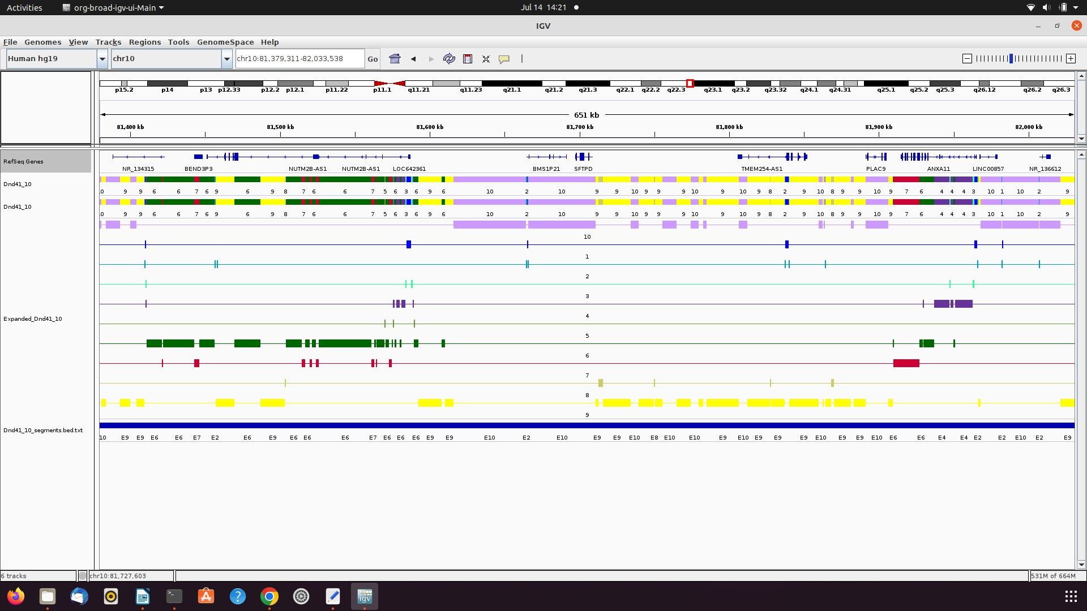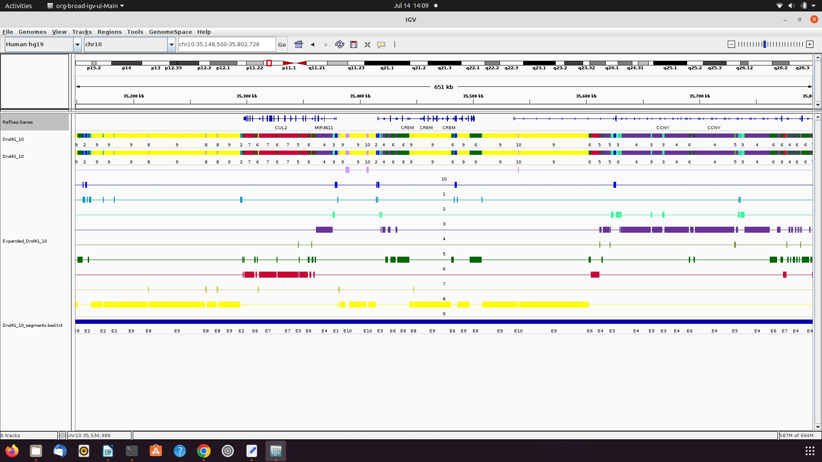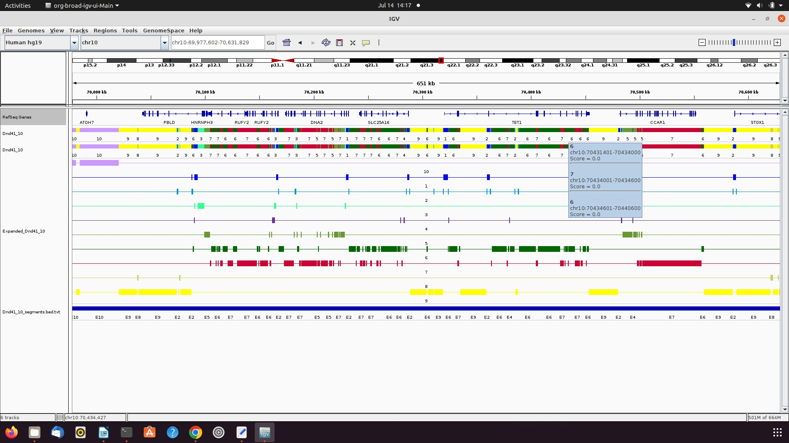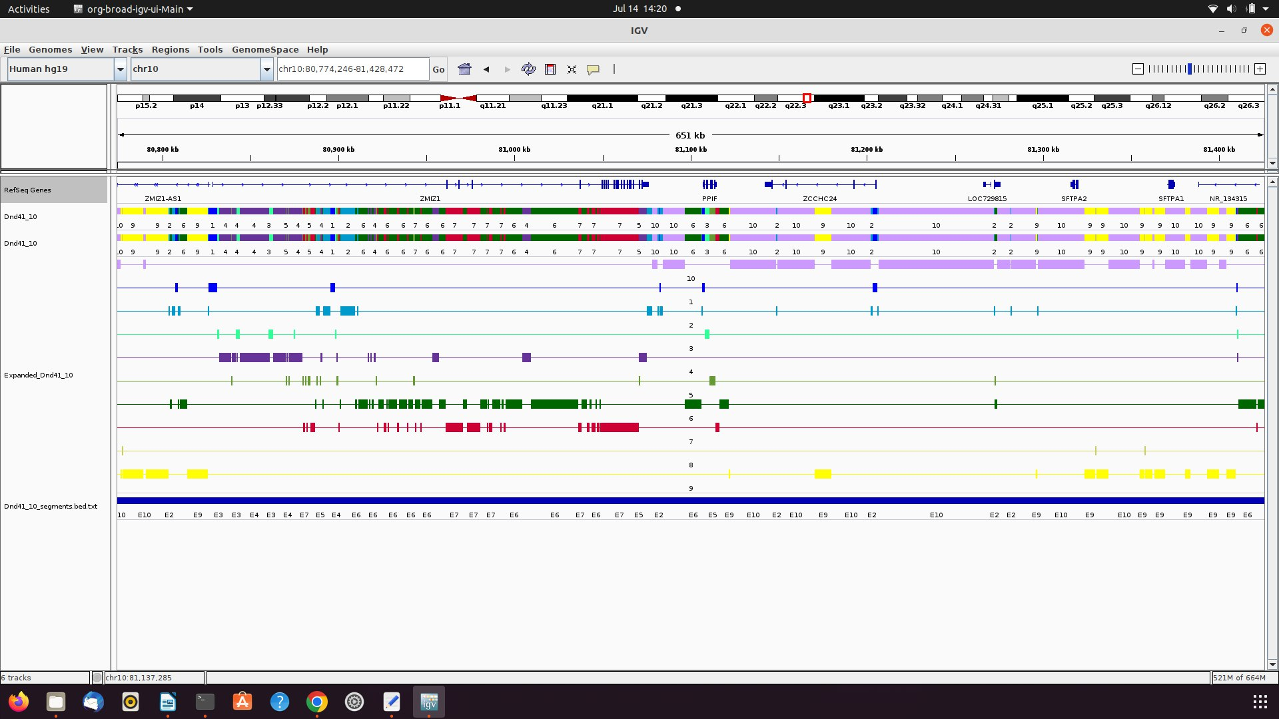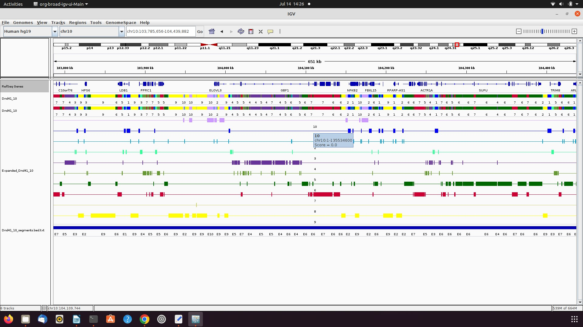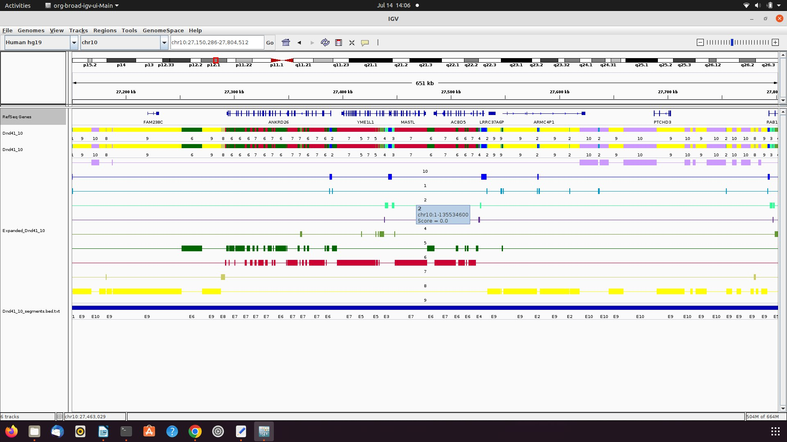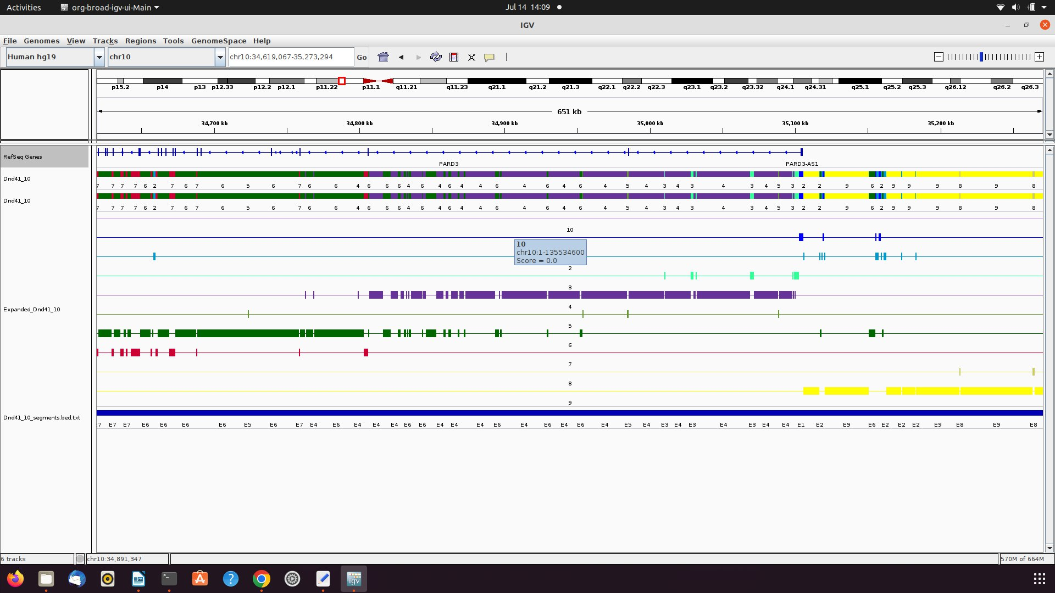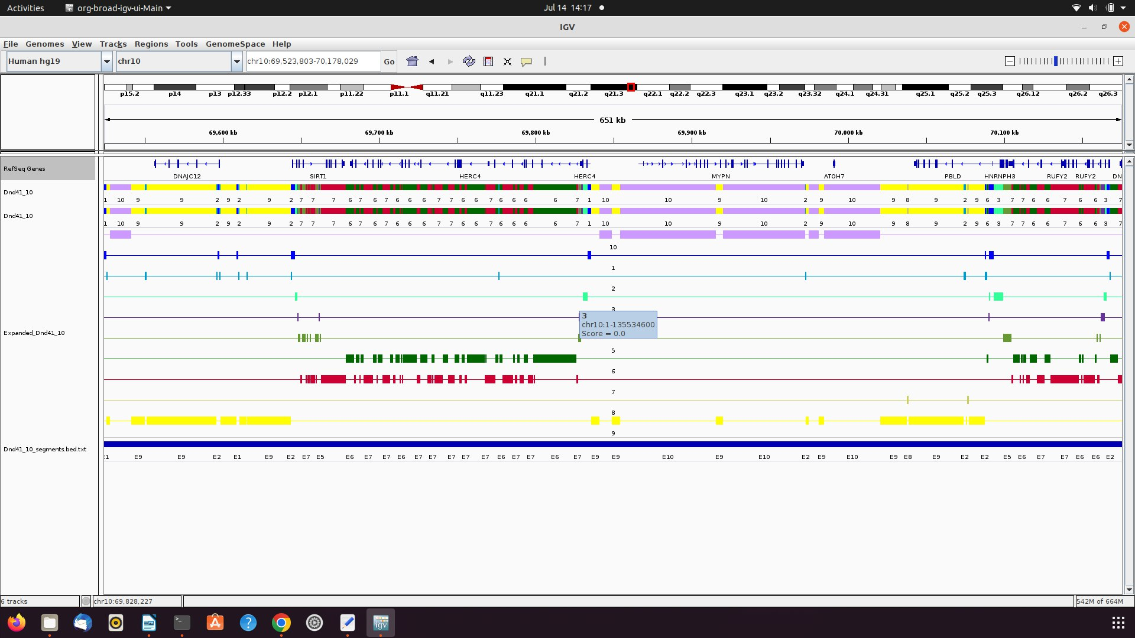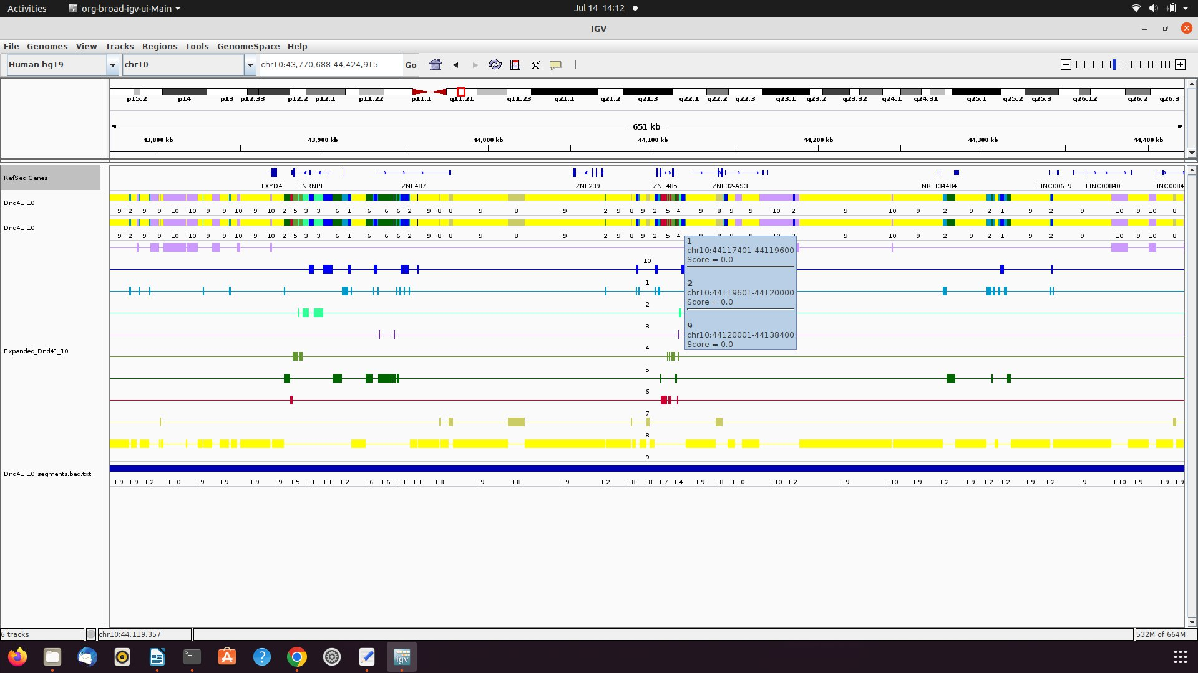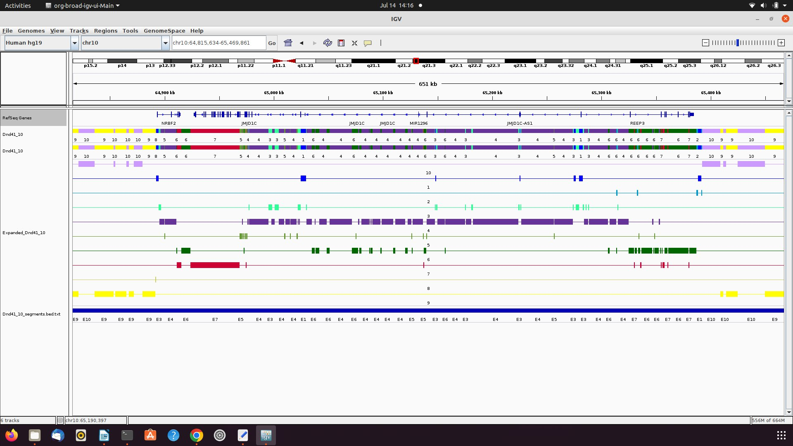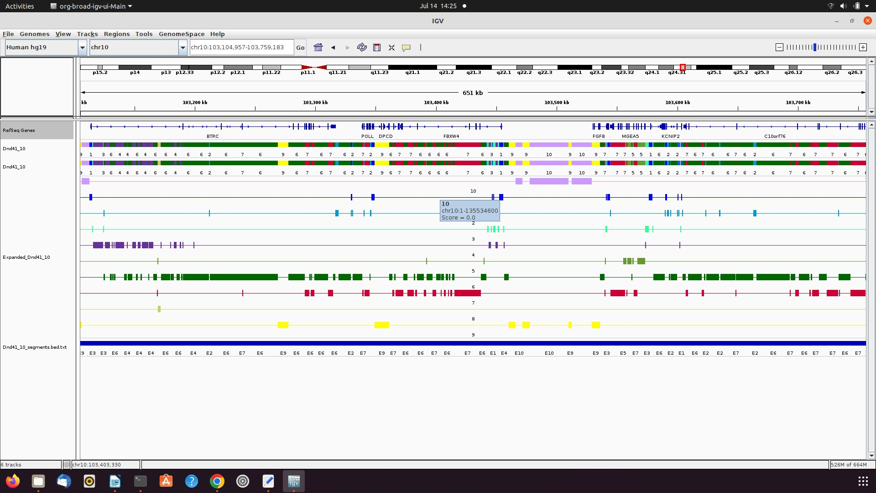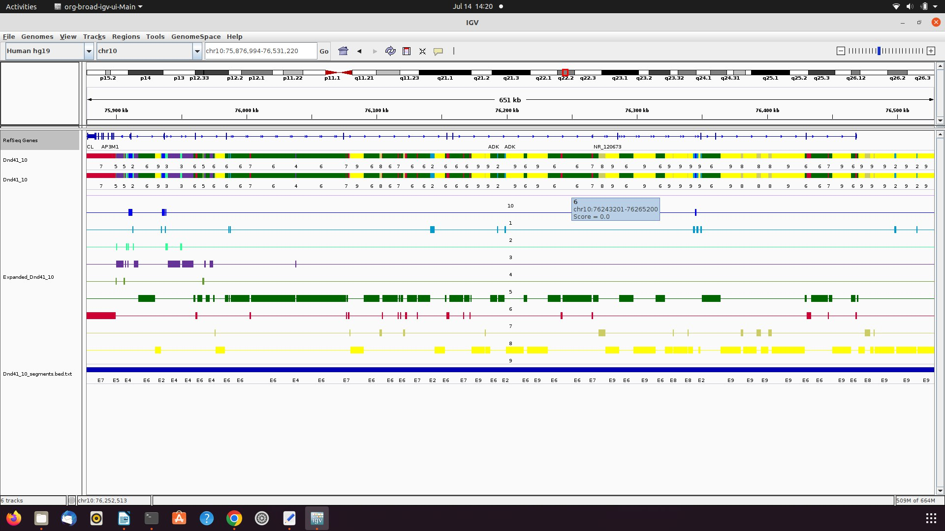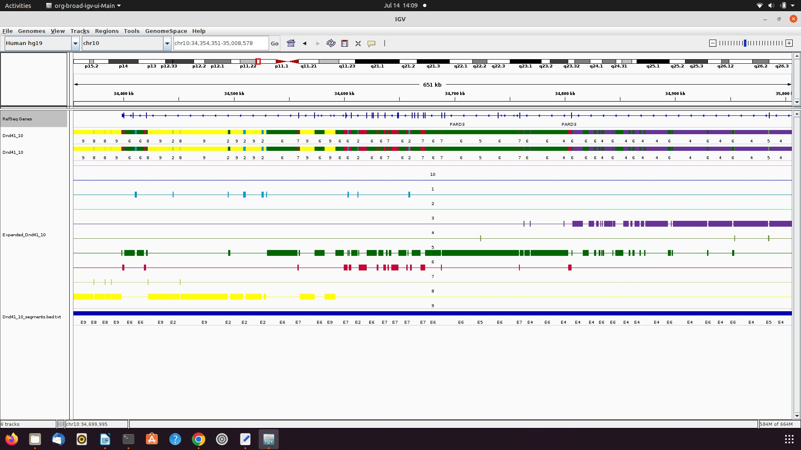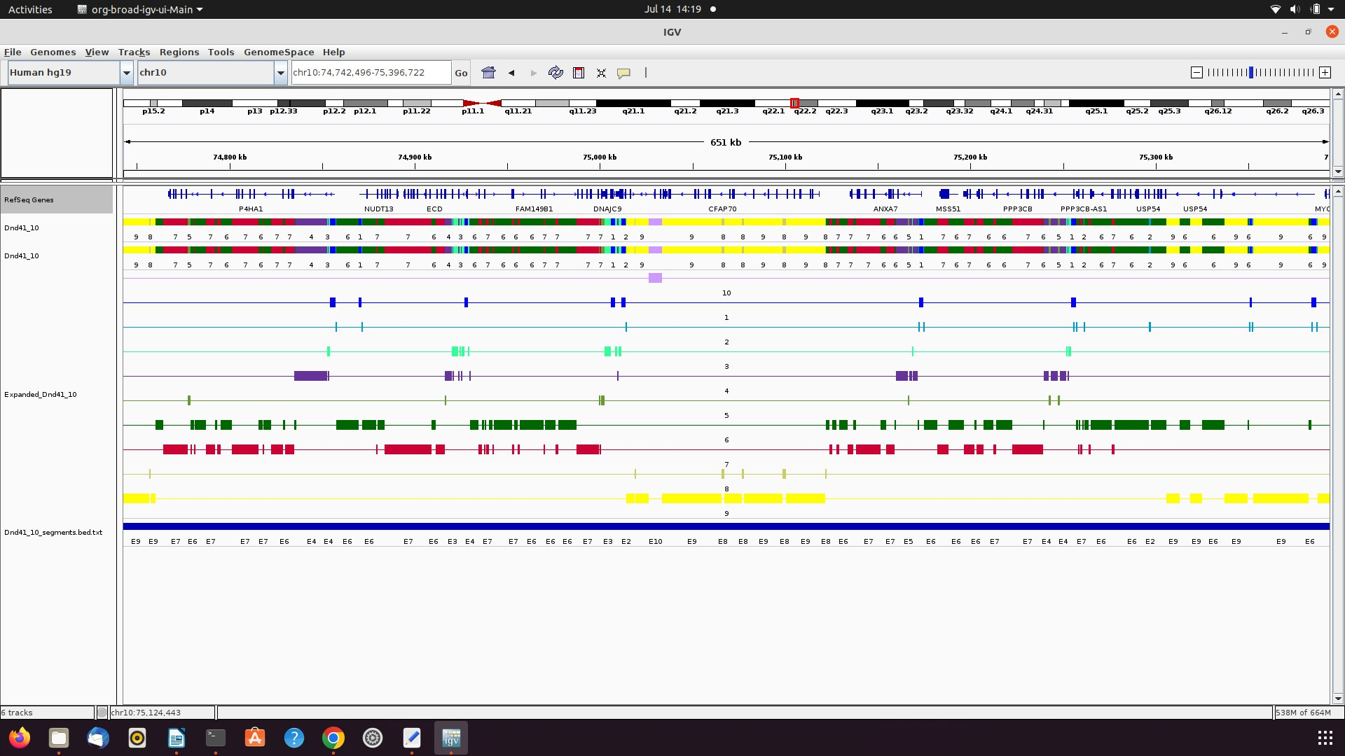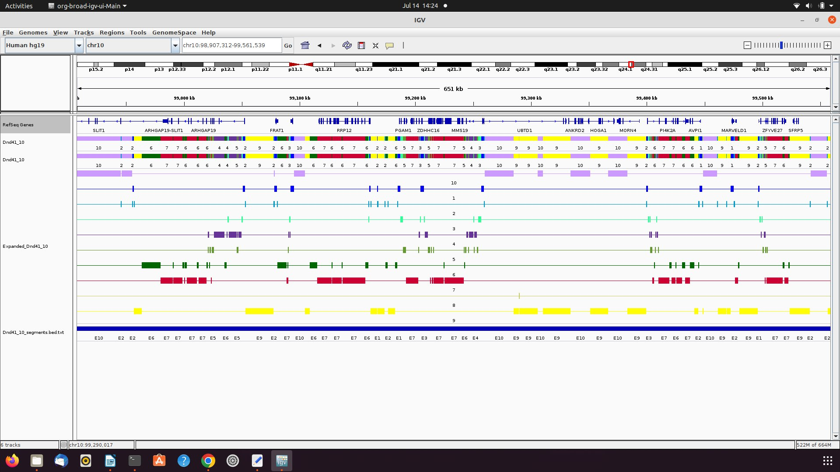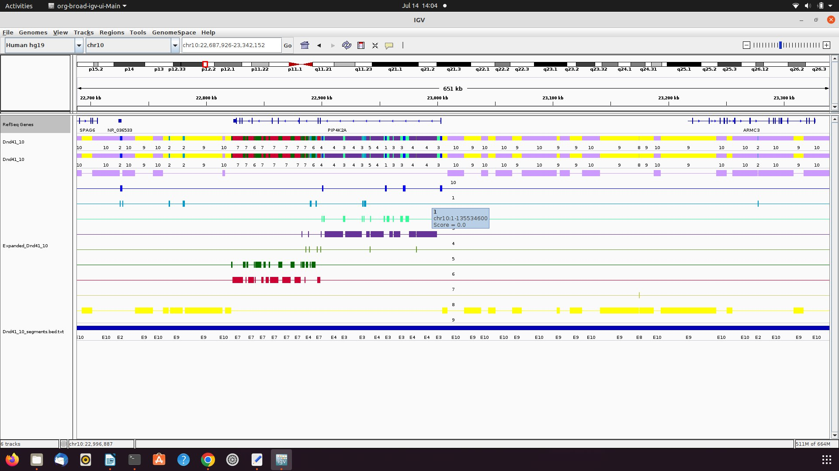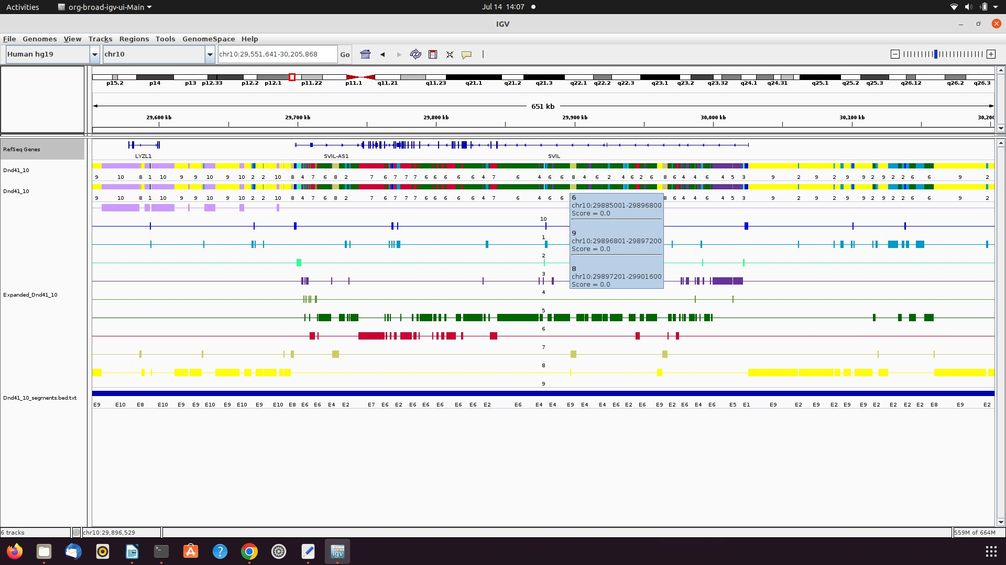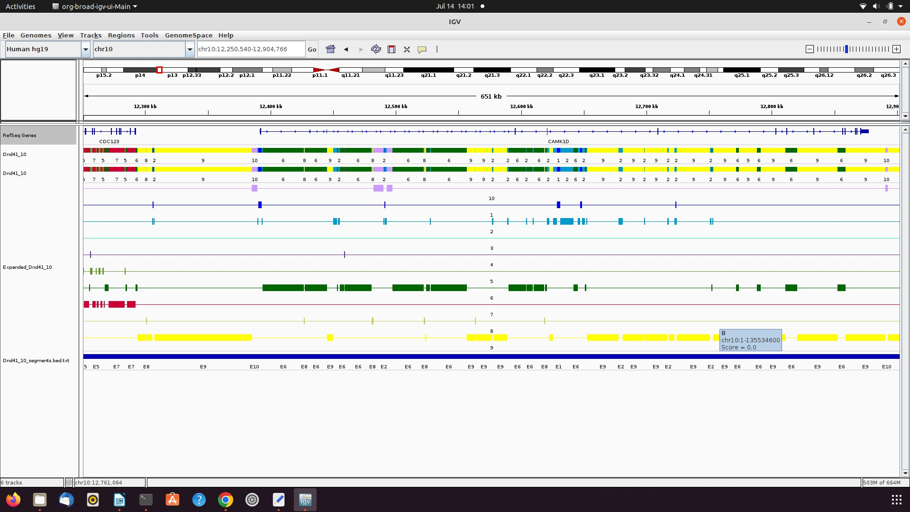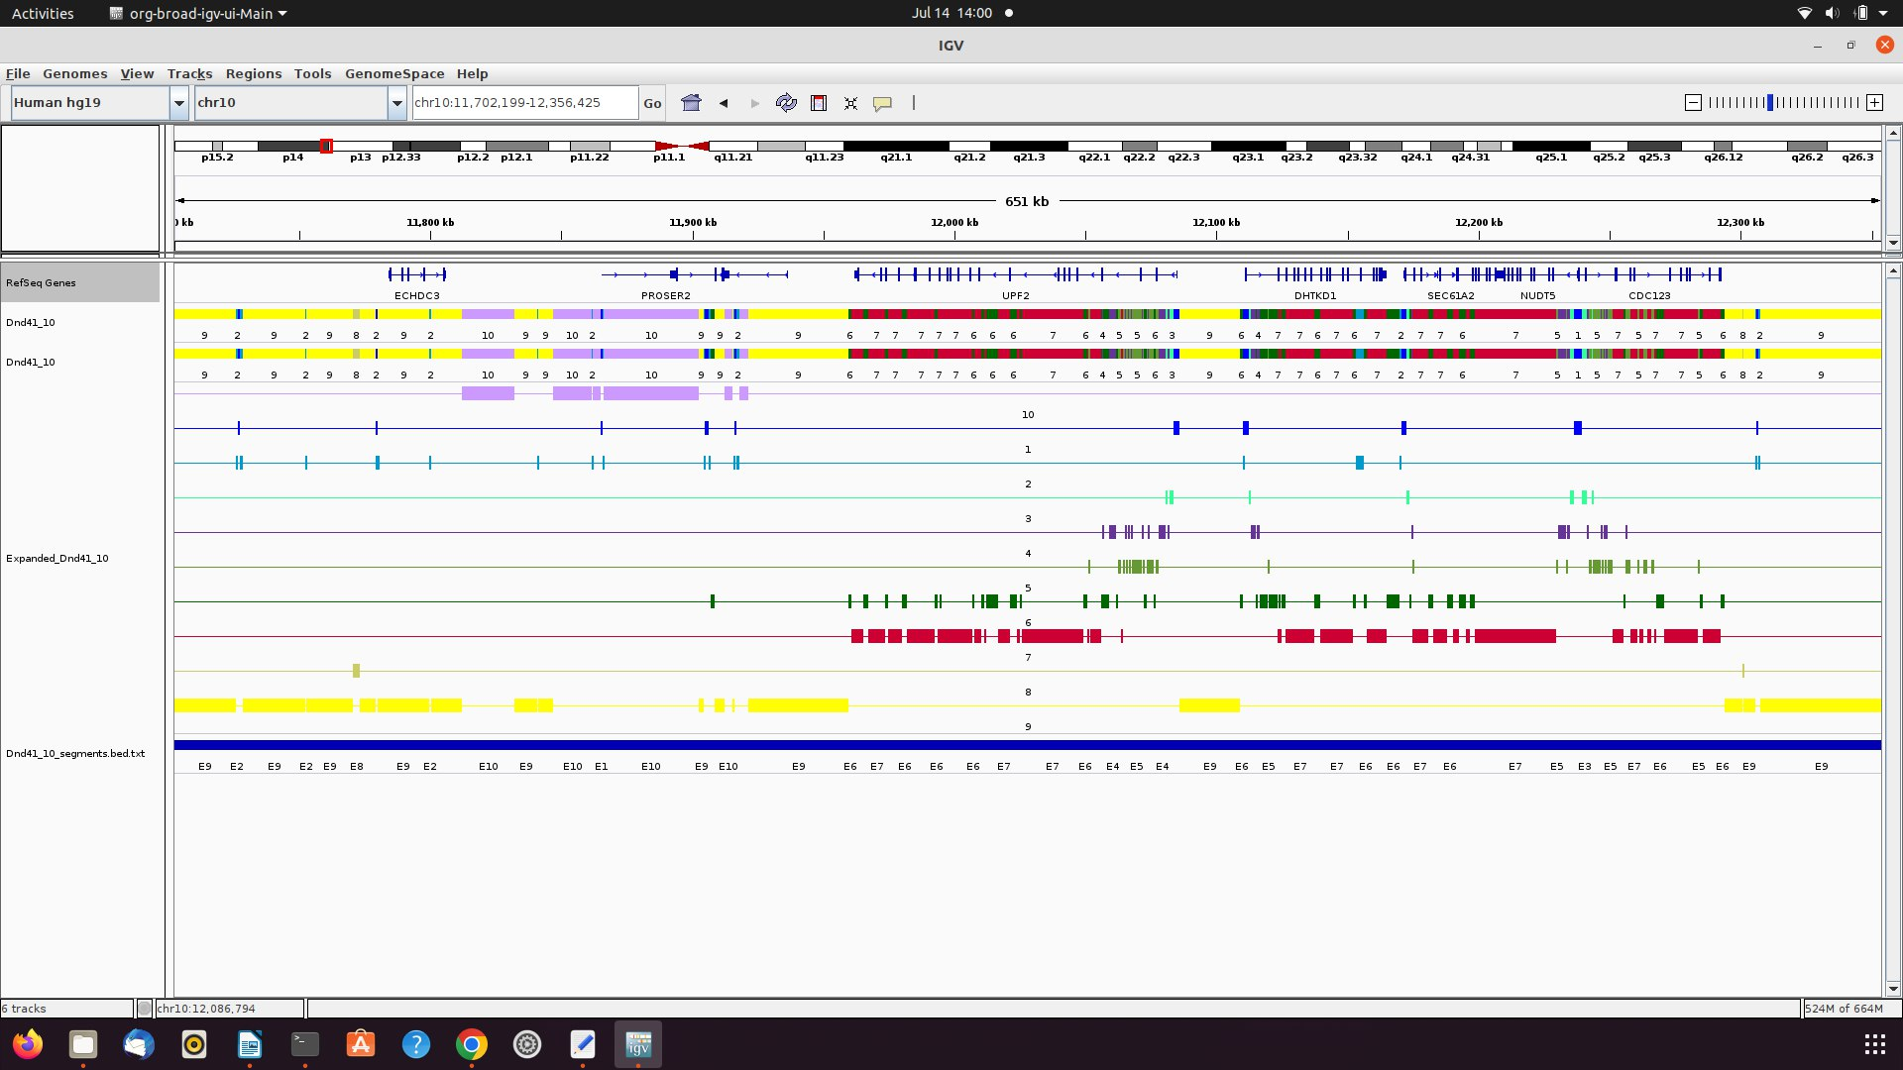

**LIST OF COMMAND USED:**

server: ssh Students@buratino.autosome.ru

password: crocoziabr

ChromHMM file download:

Wget…….

<http://hgdownload.cse.ucsc.edu/goldenPath/hg19/encodeDCC/wgEncodeBroadHistone/wgEncodeBroadHistoneDnd41ControlStdAlnRep1.bam>

<http://hgdownload.cse.ucsc.edu/goldenPath/hg19/encodeDCC/wgEncodeBroadHistone/wgEncodeBroadHistoneDnd41H3k04me1AlnRep1.bam>

<http://hgdownload.cse.ucsc.edu/goldenPath/hg19/encodeDCC/wgEncodeBroadHistone/wgEncodeBroadHistoneDnd41H3k04me2AlnRep1.bam>

<http://hgdownload.cse.ucsc.edu/goldenPath/hg19/encodeDCC/wgEncodeBroadHistone/wgEncodeBroadHistoneDnd41H3k04me3AlnRep1.bam>

<http://hgdownload.cse.ucsc.edu/goldenPath/hg19/encodeDCC/wgEncodeBroadHistone/wgEncodeBroadHistoneDnd41H3k09me3AlnRep1.bam>

<http://hgdownload.cse.ucsc.edu/goldenPath/hg19/encodeDCC/wgEncodeBroadHistone/wgEncodeBroadHistoneDnd41H3k27acAlnRep1.bam>

<http://hgdownload.cse.ucsc.edu/goldenPath/hg19/encodeDCC/wgEncodeBroadHistone/wgEncodeBroadHistoneDnd41H3k27me3AlnRep1.bam>

<http://hgdownload.cse.ucsc.edu/goldenPath/hg19/encodeDCC/wgEncodeBroadHistone/wgEncodeBroadHistoneDnd41H3k09acAlnRep1.bam>

<http://hgdownload.cse.ucsc.edu/goldenPath/hg19/encodeDCC/wgEncodeBroadHistone/wgEncodeBroadHistoneDnd41H3k36me3AlnRep1.bam>

<http://hgdownload.cse.ucsc.edu/goldenPath/hg19/encodeDCC/wgEncodeBroadHistone/wgEncodeBroadHistoneDnd41H3k79me2AlnRep1.bam>

<http://hgdownload.cse.ucsc.edu/goldenPath/hg19/encodeDCC/wgEncodeBroadHistone/wgEncodeBroadHistoneDnd41H4k20me1AlnRep1.bam>

java -mx1600M -jar ChromHMM.jar BinarizeBam CHROMSIZES\hg18.txt INPUTBAMFILES cellmarkfile.txt SAMPLEDATA_HG18

java -mx1600M -jar ChromHMM.jar BinarizeBam CHROMSIZES\hg18.txt Home cellmarkfile.txt SAMPLEDATA_HG18

java -mx1600M -jar ChromHMM.jar LearnModel -p 0 SAMPLEDATA HG18 OUTPUTSAMPLE 10 gh18

**Codes:**

ln -s ~/soft/ChromHMM/ChromHMM.jar

ln -s ~/soft/ChromHMM/CHROMSIZES

BinarizeBam -b 200 -c ~/DeborahOganyaOgenyi/OMICS4/Dnd41_control.bam

java -mx5000M -jar ~/DeborahOganyaOgenyi/OMICS4/chromm/ChromHMM.jar BinarizeBam -b 200

java -mx1600M -jar ChromHMM.jar BinarizeBam CHROMSIZES\hg18.txt INPUTBAMFILES cellmarkfile.txt SAMPLEDATA_HG18

java -mx1600M -jar ChromHMM.jar BinarizeBam CHROMSIZES\hg18.txt Home cellmarkfile.txt SAMPLEDATA_HG18

java -mx1600M -jar ChromHMM.jar LearnModel -p 0 SAMPLEDATA HG18 OUTPUTSAMPLE 10 gh18

java -mx5000M -jar ChromHMM.jar BinarizeBam -b 200 CHROMSIZES/hg19.txt data cellmarkfiletable.txt binarizedData

java -mx1200M -jar ChromHMM.jar LearnModel binarizedData learn//model 10 hg19

BinarizeBam -b 200 -c ~/DeborahOganyaOgenyi/OMICS4/Dnd41_control.bam

java -mx5000M -jar ~/DeborahOganyaOgenyi/OMICS4/chromm/ChromHMM.jar BinarizeBam -b 200

**Files Downloaded to home:**

/home/deborah/wgEncodeBroadHistoneDnd41ControlStdAlnRep1.bam

/home/deborah/wgEncodeBroadHistoneDnd41H3k04me1AlnRep1.bam

/home/deborah/wgEncodeBroadHistoneDnd41H3k04me2AlnRep1.bam

/home/deborah/wgEncodeBroadHistoneDnd41H3k04me3AlnRep1.bam

/home/deborah/wgEncodeBroadHistoneDnd41H3k09acAlnRep1.bam

/home/deborah/wgEncodeBroadHistoneDnd41H3k09me3AlnRep1.bam

/home/deborah/wgEncodeBroadHistoneDnd41H3k27acAlnRep1.bam

/home/deborah/wgEncodeBroadHistoneDnd41H3k27me3AlnRep1.bam

/home/deborah/wgEncodeBroadHistoneDnd41H3k36me3AlnRep1.bam

/home/deborah/wgEncodeBroadHistoneDnd41H3k79me2AlnRep1.bam

/home/deborah/wgEncodeBroadHistoneDnd41H4k20me1AlnRep1.bam

**cellmarkfiletable.txt**

Dnd41 H3k04 wgEncodeBroadHistoneDnd41H3k04me1AlnRep1.bam

wgEncodeBroadHistoneDnd41ControlStdAlnRep1.bam

Dnd41 H3k04 wgEncodeBroadHistoneDnd41H3k04me2AlnRep1.bam

wgEncodeBroadHistoneDnd41ControlStdAlnRep1.bam

Dnd41 H3k04 wgEncodeBroadHistoneDnd41H3k04me3AlnRep1.bam

wgEncodeBroadHistoneDnd41ControlStdAlnRep1.bam

Dnd41 H3k09 wgEncodeBroadHistoneDnd41H3k09acAlnRep1.bam

wgEncodeBroadHistoneDnd41ControlStdAlnRep1.bam

Dnd41 H3k09 wgEncodeBroadHistoneDnd41H3k09me3AlnRep1.bam

wgEncodeBroadHistoneDnd41ControlStdAlnRep1.bam

Dnd41 H3k27 wgEncodeBroadHistoneDnd41H3k27acAlnRep1.bam

wgEncodeBroadHistoneDnd41ControlStdAlnRep1.bam

Dnd41 H3k27 wgEncodeBroadHistoneDnd41H3k27me3AlnRep1.bam

wgEncodeBroadHistoneDnd41ControlStdAlnRep1.bam

Dnd41 H3k36 wgEncodeBroadHistoneDnd41H3k36me3AlnRep1.bam

wgEncodeBroadHistoneDnd41ControlStdAlnRep1.bam

Dnd41 H3k79 wgEncodeBroadHistoneDnd41H3k79me2AlnRep1.bam

wgEncodeBroadHistoneDnd41ControlStdAlnRep1.bam

Dnd41 H4k20 wgEncodeBroadHistoneDnd41H4k20me1AlnRep1.bam

wgEncodeBroadHistoneDnd41ControlStdAlnRep1.bam

~/DeborahOganyaOgenyi/OMICS4/chromm/CHROMSIZES/hg19.txt ~/DeborahOganyaOgenyi/OMICS4/chip_seq ~/DeborahOganyaOgenyi/OMICS4/cellmarkfiletable.txt ~/DeborahOganyaOgenyi/OMICS4/binarizedData

screen -S DeborahOganyaOgenyilearn2 java -mx5000M -jar ~/DeborahOganyaOgenyi/OMICS4/chromm/ChromHMM.jar LearnModel -b 200 ~/DeborahOganyaOgenyi/OMICS4/binarizedData ~/DeborahOganyaOgenyi/OMICS4/learnmodel3 10 hg19

**Files used in sever:**

wgEncodeBroadHistoneDnd41ControlStdAlnRep1.bam wgEncodeBroadHistoneDnd41H3k04me2AlnRep1.bam wgEncodeBroadHistoneDnd41H3k27acAlnRep1.bam wgEncodeBroadHistoneDnd41H4k20me1AlnRep1.bam

wgEncodeBroadHistoneDnd41H2azAlnRep1.bam wgEncodeBroadHistoneDnd41H3k04me3AlnRep1.bam wgEncodeBroadHistoneDnd41H3k27me3AlnRep1.bam

wgEncodeBroadHistoneDnd41H3k04me1AlnRep1.bam wgEncodeBroadHistoneDnd41H3k09acAlnRep1.bam wgEncodeBroadHistoneDnd41H3k36me3AlnRep1.bam

wgEncodeBroadHistoneDnd41H3k04me1AlnRep1.bam.1 wgEncodeBroadHistoneDnd41H3k09me3AlnRep1.bam wgEncodeBroadHistoneDnd41H3k79me2AlnRep1.bam

**Figshare files:**

https://figshare.com/articles/dataset/Untitled_Item/20311830?file=36285672

https://figshare.com/articles/dataset/Untitled_Item/20311830?file=36285675

https://figshare.com/articles/dataset/Untitled_Item/20311830?file=36285678

https://figshare.com/articles/dataset/Untitled_Item/20311830?file=36285681

**IGV FILES:**

2022-07-14 12:40:17 INFO IGV:1345 - Loading 1 resources.

2022-07-14 12:40:17 INFO TrackLoader:122 - Loading resource, path /home/deborah/Downloads/Dnd41_10_dense.bed

2022-07-14 12:40:39 INFO IGV:1345 - Loading 1 resources.

2022-07-14 12:40:39 INFO TrackLoader:122 - Loading resource, path /home/deborah/Downloads/Dnd41_10_dense.bed.fai

2022-07-14 12:40:39 INFO MessageUtils:76 - <html>Unknown file type: /home/deborah/Downloads/Dnd41_10_dense.bed.fai<br>Check file extension

2022-07-14 12:40:51 INFO IGV:1345 - Loading 1 resources.

2022-07-14 12:40:51 INFO TrackLoader:122 - Loading resource, path /home/deborah/Downloads/Dnd41_10_dense.bed.txt

2022-07-14 12:41:10 INFO IGV:1345 - Loading 1 resources.

2022-07-14 12:41:10 INFO TrackLoader:122 - Loading resource, path /home/deborah/Downloads/Dnd41_10_expanded.bed.txt

2022-07-14 12:41:24 INFO IGV:1345 - Loading 1 resources.

2022-07-14 12:41:24 INFO TrackLoader:122 - Loading resource, path /home/deborah/Downloads/Dnd41_10_segments.bed.txt

**Result on server:**

~/DeborahOganyaOgenyi/OMICS4/learnModel